**Michael Belmes 0915 541 7085 michaelbelmes2016@gmail.com**

30+ Years Coaching Experience

American Swimming Coaches Association Certified Pool Manager

Proven Aquatics Program Builder

Proven Coach of Elite Swimmers

Creator of Proven Instruction Program

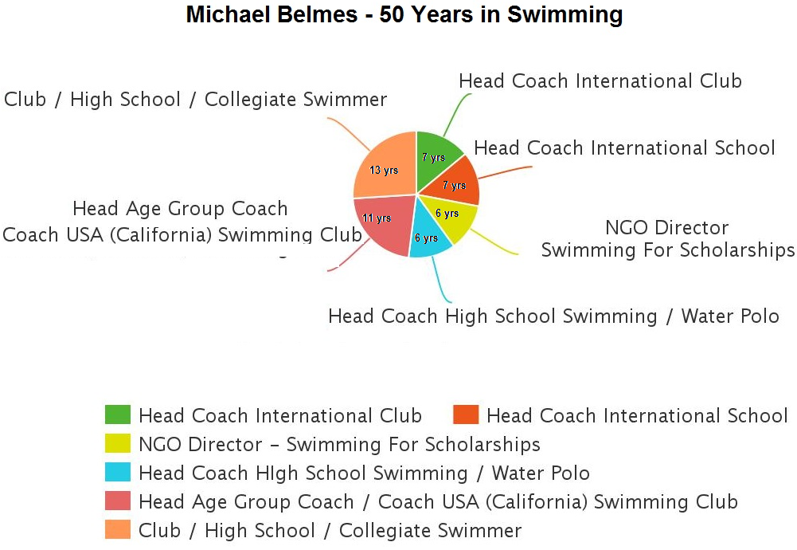

**Coaching Highlights**

Saigon Swordfish: ISHCMC Invitational 2015 Outstanding Swimmer Awardee

Saigon Swordfish: BIS Phuket Invitational 2015 Outstanding Swimmer Awardee

Saigon Swordfish: Bangkok Splash Event Champions

Saigon Swordfish: Numerous Outstanding Swimmer Awardees – City Championships

Saigon South International School: Last Place To Champion (Secondary Boys) in 1 Year.

Saigon South International School: UNIS Invitational Team Performance Champion, 2010

Saigon South International School: UNIS Invitational Team Performance Runner-Up 2009

ABC International School: FOBISSEA 2008 – 15 Gold Medals

Vietnam National Water Polo Team – Best SEA Games Won/Lost Record in history.

Vietnam National Water Polo Team – 1st International Win.

Campbell Wavemakers – Largest 1-year improvement in Zone 1 South Championships History. From 23rd Place to 6th in 6 months.

National Capitol Region Elite Development Group – 6 National Records Broken

Swimming For Scholarships – Nearly 50 Full College Scholarships attained through the free swimming training provided

Los Gatos High School – 3 All Americans (2 Water Polo / 1 Swimming)

Los Gatos High School – Central Coast Section (Top-3 Sections in the USA) Runner Up – Water Polo with no deep water training pool

Los Gatos High School – Central Coast Section (200 schools) Top – 10 every year with 0 Club Swimmers

**Swimming Highlights**

1980 – Foothill College: All-American 100 Breaststroke

1979 - Bellarmine College Preparatory: All-American 100 Breaststroke and 200 Medley Relay

1979 – Bellarmine College Preparatory: Central Coast Section 3-Time Champion. One of less than a dozen swimmers in Central Coast Section History to win 3 events in the Finals.

1978 – Bellarmine College Preparatory: All-American Honorable Mention 100 Breaststroke.

1976 – Camden Swim Club: Pacific Association (California, Oregon and Washington) Record 200 Medley Relay and 400 Medley Relay

1976 – Camden Swim Club: Ranked Top-10 in the USA 100 Breaststroke and 200 IM.

1976 – Camden Swim Club: Far Westerns Champion in 3 Events; 100 Breaststroke, 200 Medley Relay and 400 Medley Relay

1974 – Los Altos Aquatic Club: Ranked Top-10 in the USA; 100 Breaststroke and 200 IM

1972 – Los Altos Aquatic Club: Ranked Top-10 in the USA; 50 Breaststroke

1972 – Los Altos Aquatic Club (now LAMVAC – Los Altos Mountain View Aquatic Club – Still holds numerous team records.

**Coaching History**

**Michael Belmes Aquatics (Saigon Swordfish)** – Director/Head Coach 7/10- 7/16

Full swimming lessons program / competitive swimming team, water polo and masters club has grown from 6 initial swimmers to over 100 with over 20 classes per week. 2 contracts to instruct/coach at local international schools. Direct 5 assistants.

**Saigon South International School** – Swimming Instructor / Head Coach 6/08 – 6/10

Nguyen Van Linh Parkway, Tan Phong Ward, District 7, Ho Chi Minh City

Swimming instructor working within the P.E. Department. The swim team under my leadership has grown from 30 swimmers to just under 70 in 2 years. The Middle and High School Boys teams went from last place to 1st place at City Championships within the first year. UNIS Invitational Team Performance Champions, 2010.

**ABC International School** – Head Swimming Coach 8/06 – 6/08

71 1E Street, Khu Dang Cu Trung Son, Binh Hung, Binh Chanh, Ho Chi Minh City, Vietnam

Leader of the most popular club at ABC School that began with 20 swimmers that grew to nearly 80. Responsible for creating and implementing a fun and comprehensive swimming lessons/training program. 15 Gold medals won at FOBISSEA, 2008.

**Socialist Republic of Vietnam –** Head Water Polo Coach 8/03-1/05

Vietnam Training Center #2, Thu Duc, Ho Chi Minh City, Vietnam

Head Water Polo Coach of the Vietnam National Water Polo Team. Responsible for training and strategy of the 20-member team that won it’s first international match and placed 5th in the 2003 SEA Games, Vietnam’s first, non-last place finish.

**Campbell Community Center** – Head Age Group/Masters Swimming Coach 10/00-08/02

1 W. Campbell Ave., Campbell, CA 95008

Two-year contract coaching the Campbell Wavemakers (USA Swim Team). Club grew from 50 to 120 members . Brought club from 23rd Place in Regional Championships to 6th Place in the first year. Wrote original swimming lessons program.

**National Capitol Region Elite Training Group** – Head Coach 12/98-06/99

ULTRA Training Complex, University of Life, Pasig City, Philippines

ASEAN Games Gold Medallist, 6 National Age-Group Records set and 79 National Capitol Region Records were set during my contract period.

**Hobby**

Professional musician, singer/songwriter and composer with TV credits including Star World, Channel V, Yan TV, Sunsilk and Motorola.